Upgrade the firmware manual

Upgrade package：Upgrade package-recocery password

Upgrade tools：RKDevTool_Release_v2.81

Upgrade Driver：DriverAssitant_v5.0

Upgrade mode: The device is upgraded by connecting the OTG to the PC. The upgrade procedure is as follows

1. Install the Upgrade Driver(DriverAssitant_v5.0)
2. Running the Upgrade Tool---RKDevTool_Release_v2.81----RKDevTool.exe

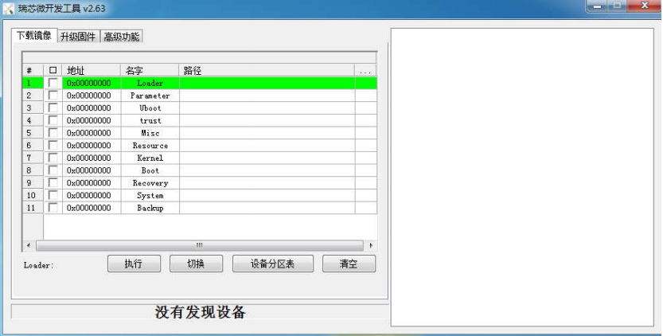

1. Insert the OTG data cable to discover the device（Please short-circuit the green line recovery and the black line GND, and then power on the 9160. The firmware upgrade mode is entered）

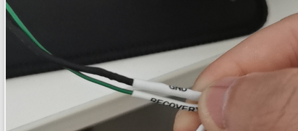 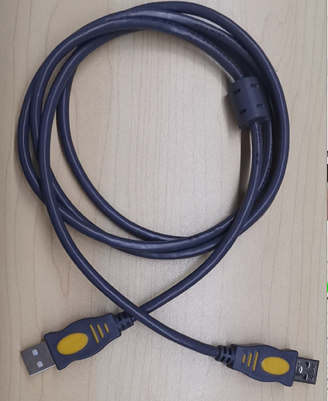

**Use a USB cable to connect the OTG port to the USB port of the computer**

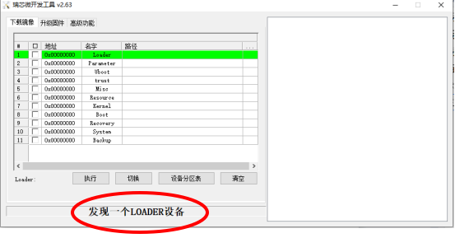

3. Right-click in the blank and select Import configuration. Find the tr08el. CFG file in the upgrade package and open it.

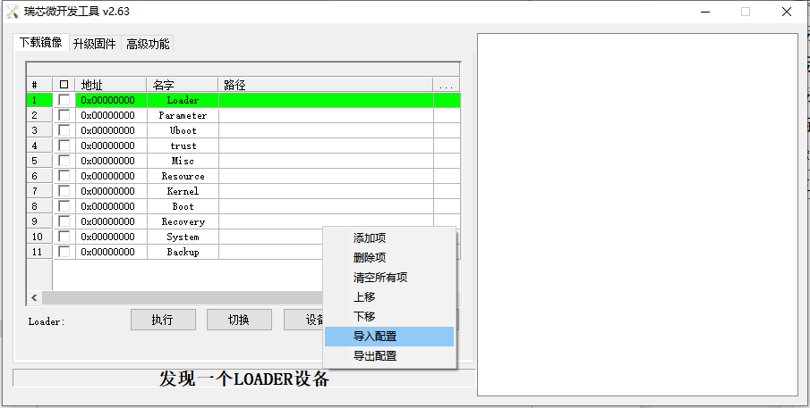

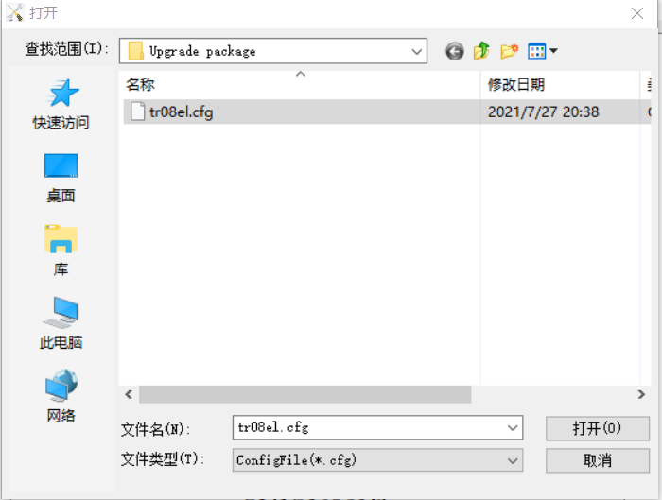

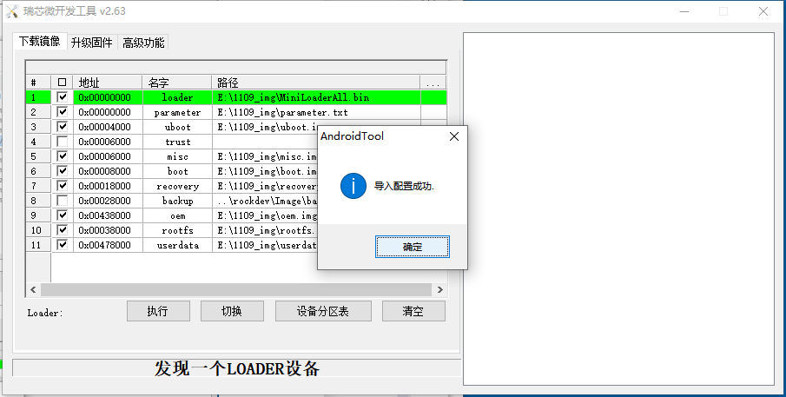

1. Click next to the checked item to select the file in the corresponding upgrade package

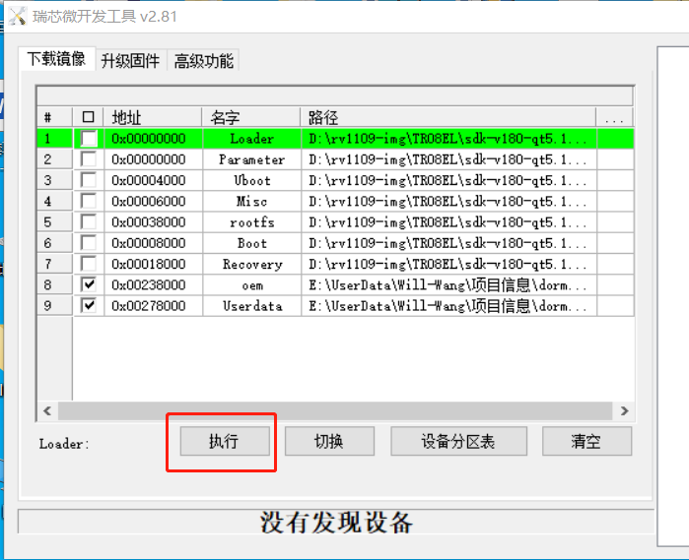

5. After selecting the file, click "执行", the device starts automatically to upgrade the firmware.

6.Finish，and then reactive the devices.